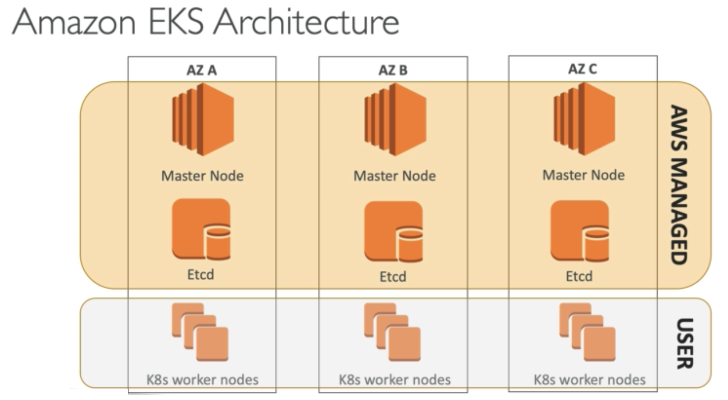

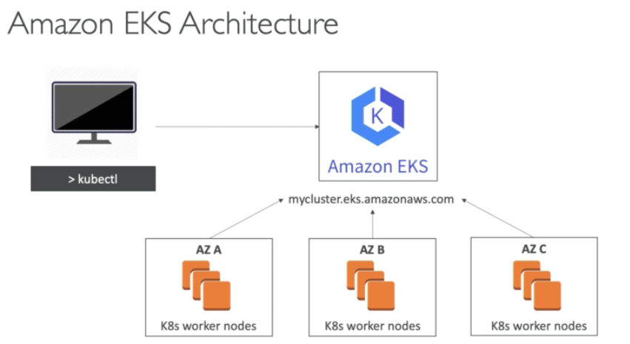

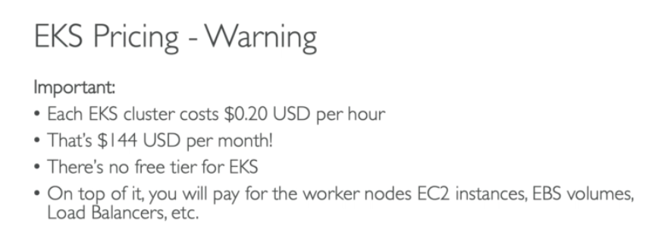

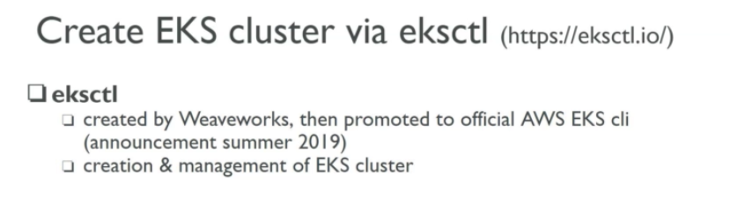

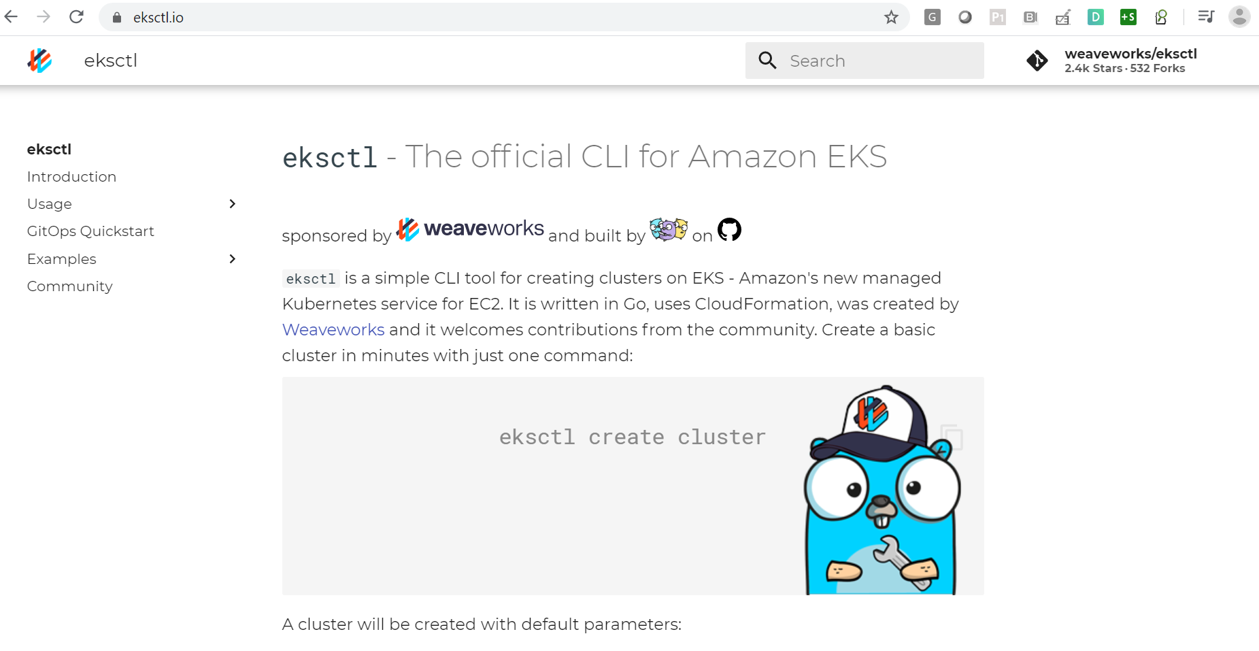

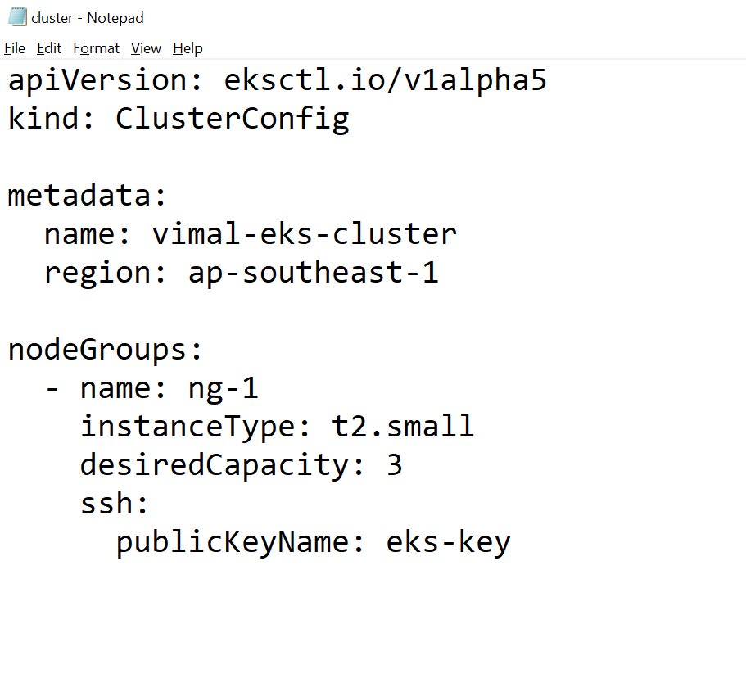

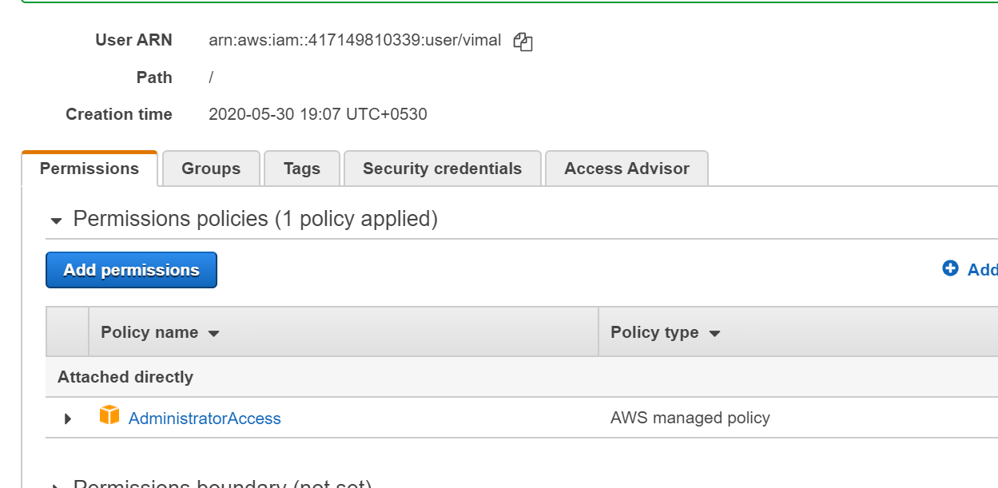

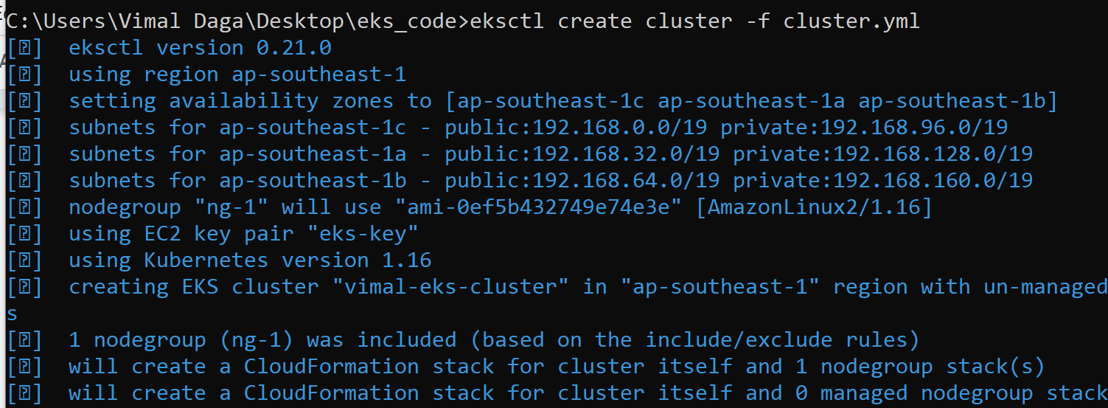

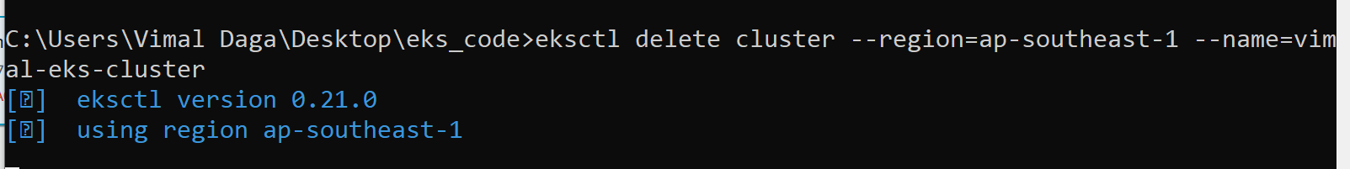

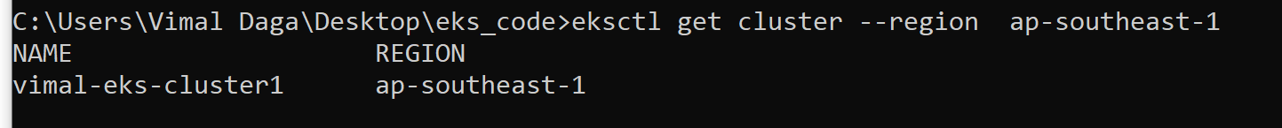

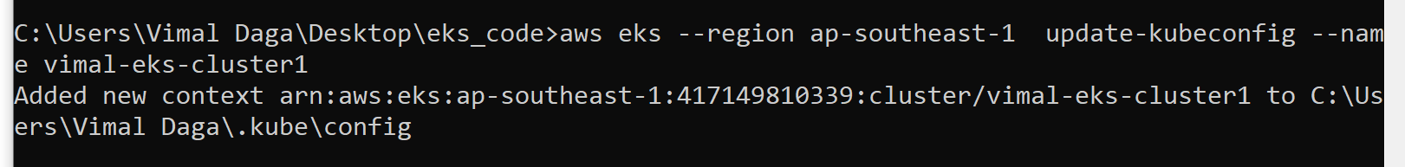

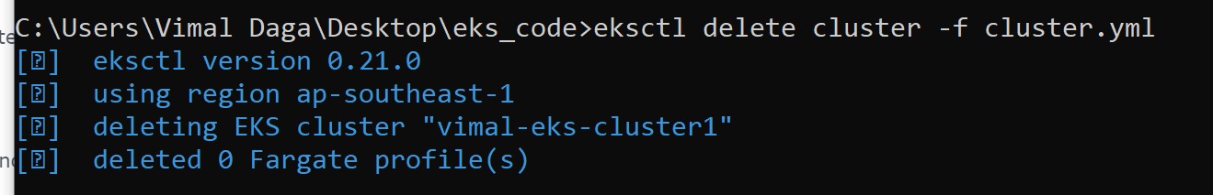

C:\Users\Vimal Daga\Desktop\eks_code>eksctl get cluster --region ap-southeast-1

C:\Users\Vimal Daga\Desktop\eks_code>eksctl get nodegroup --cluster vimal-eks-cluster1 --region ap-southeast-1

C:\Users\Vimal Daga\Desktop\eks_code>eksctl scale nodegroup --cluster vimal-eks-cluster1 --nodes=5 --name=ng-1 --nodes-max=6 --nodes-min=2 --region ap-southeast-1

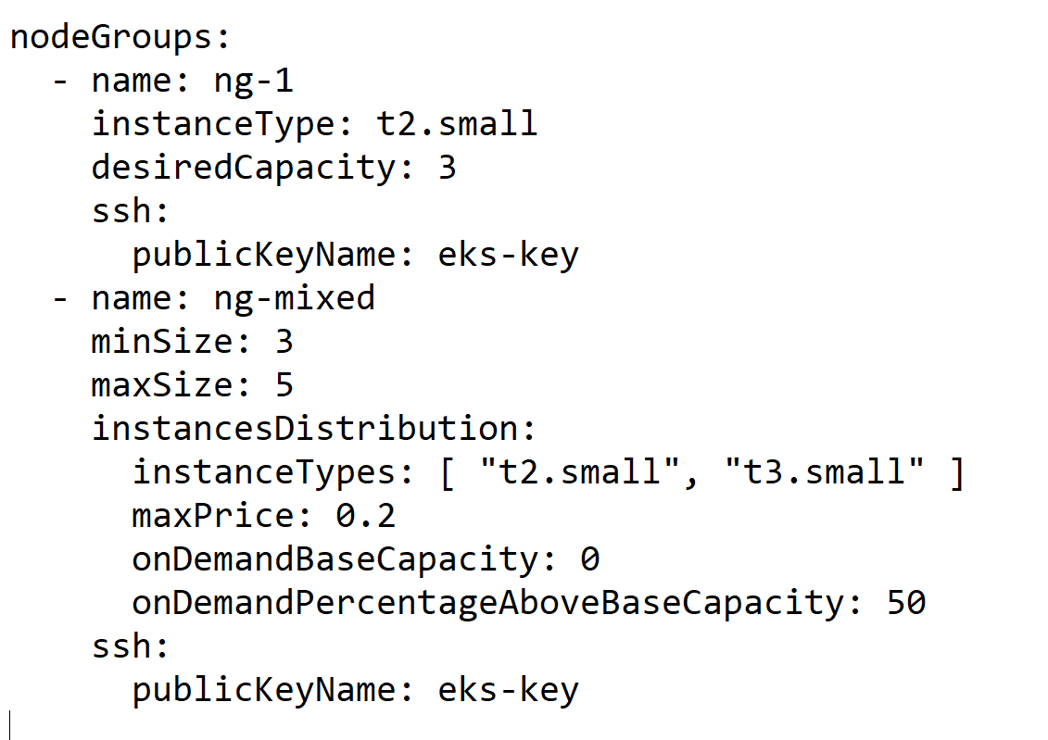

C:\Users\Vimal Daga\Desktop\eks_code>eksctl create nodegroup --config-file=cluster.yml --include="ng-mixed"

C:\Users\Vimal Daga\Desktop\eks_code>eksctl delete nodegroup --config-file=cluster.yml --include="ng-mixed" --approve

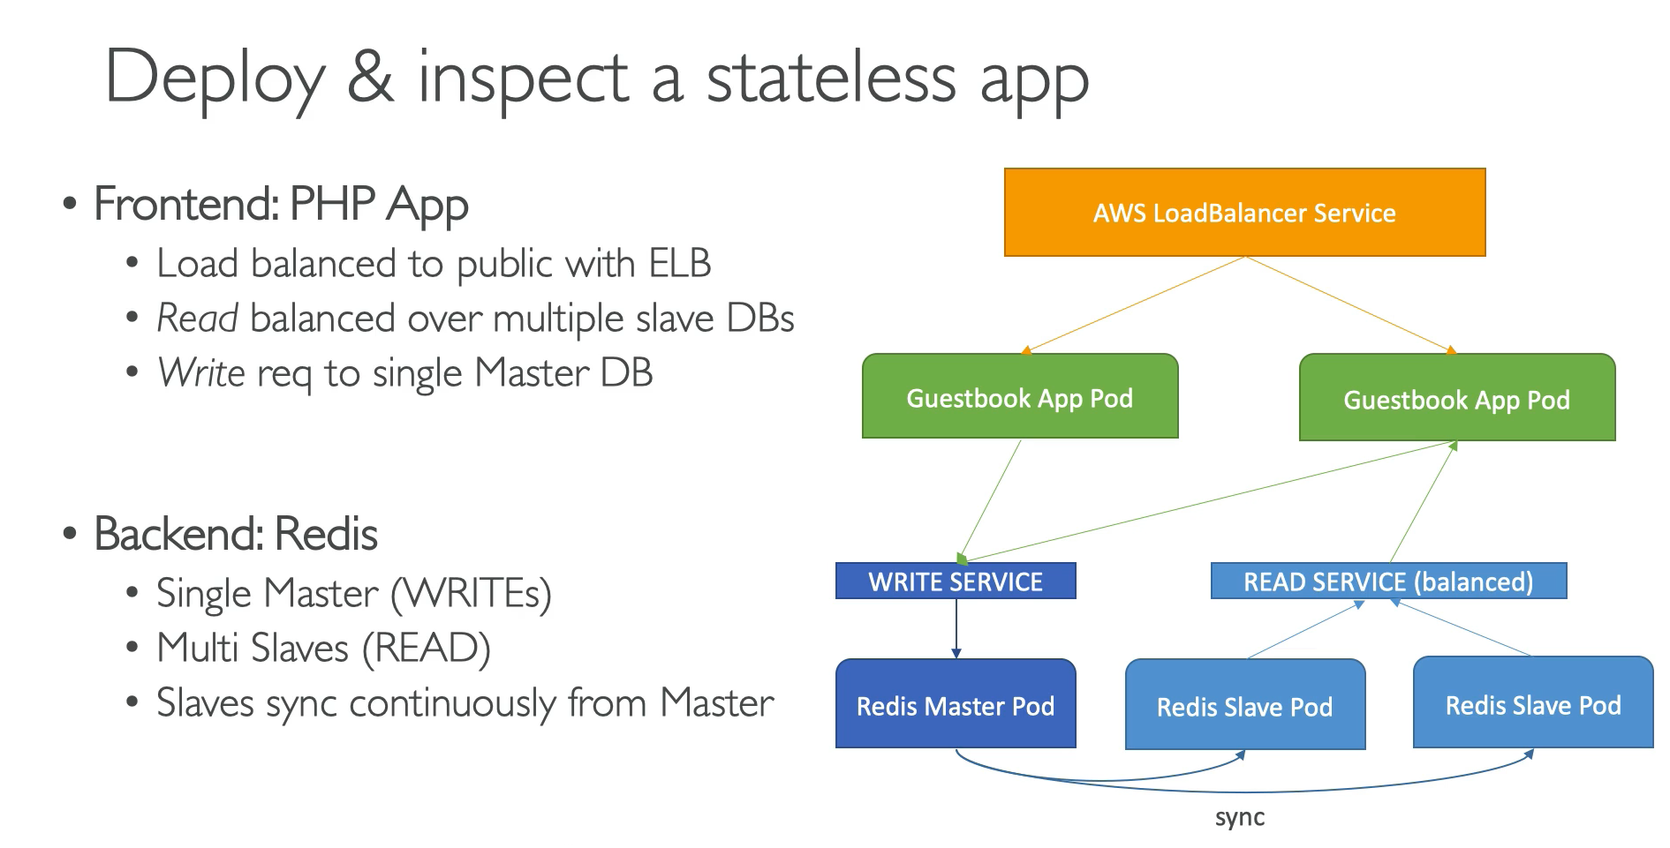

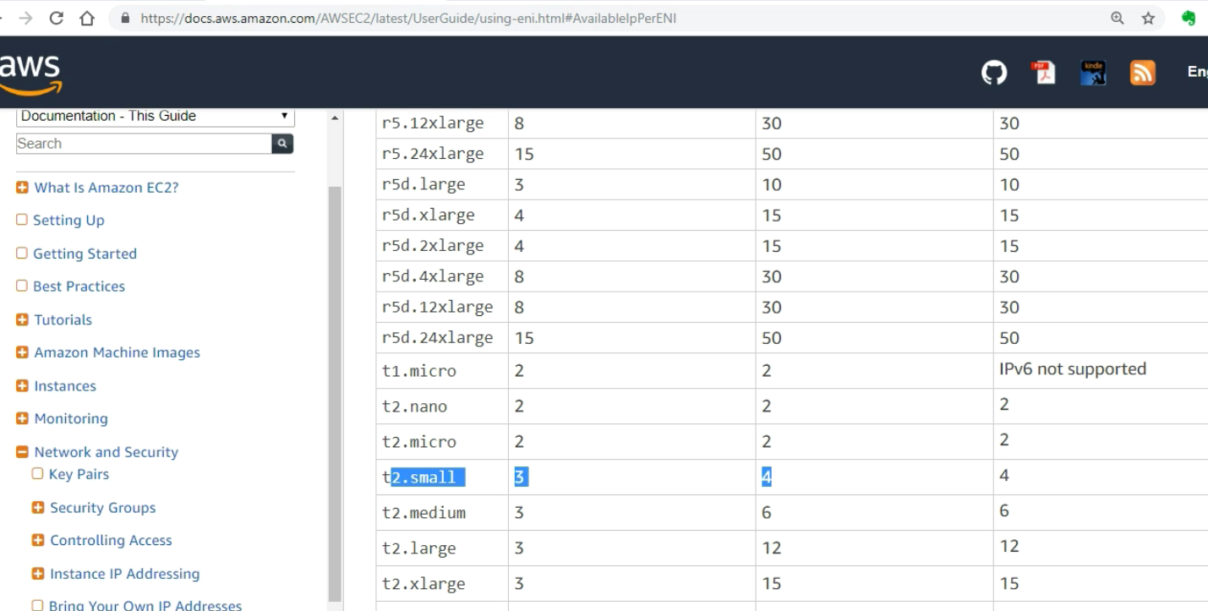

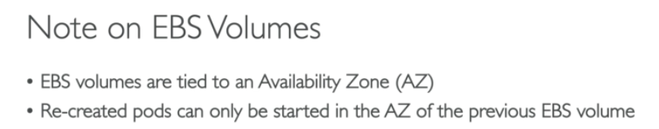

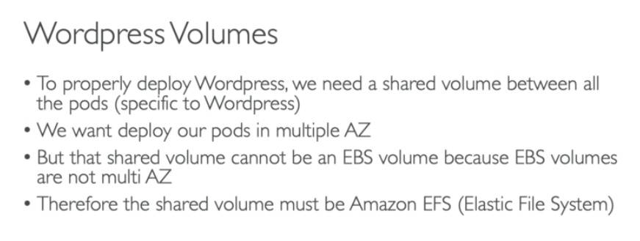

# aws eks --region ap-southeast-1 update-kubeconfig --name vimal-eks-cluster1

# kubectl create namespace lwapp

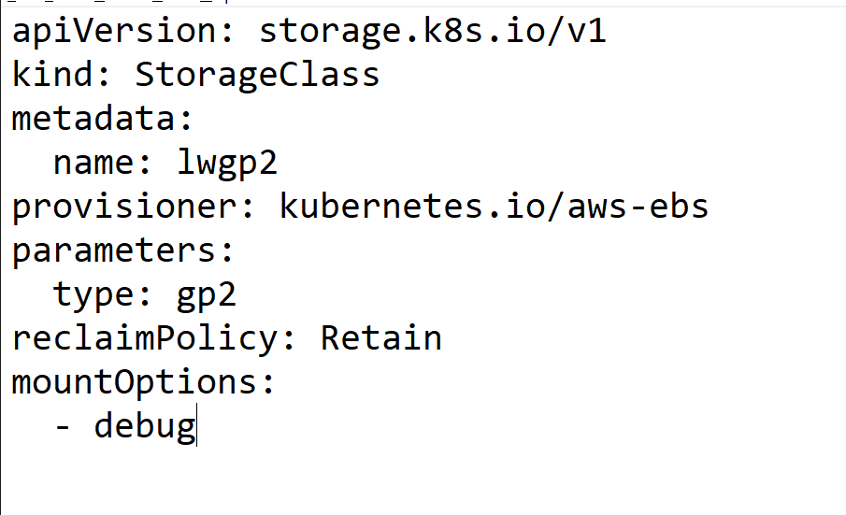

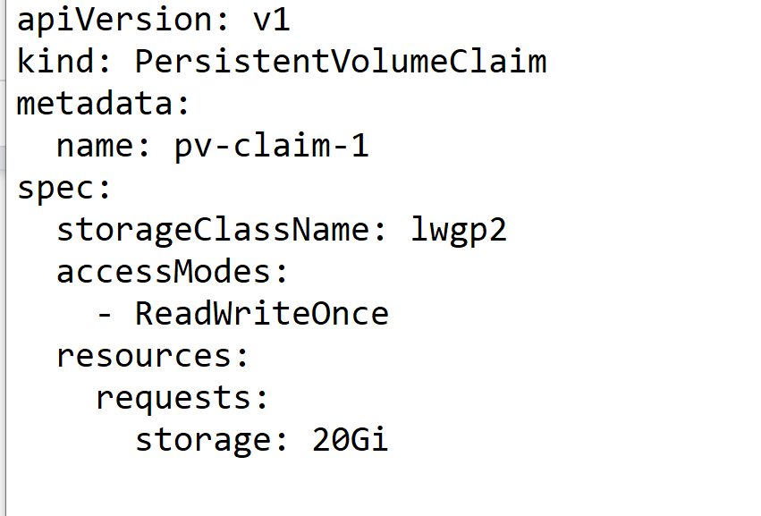

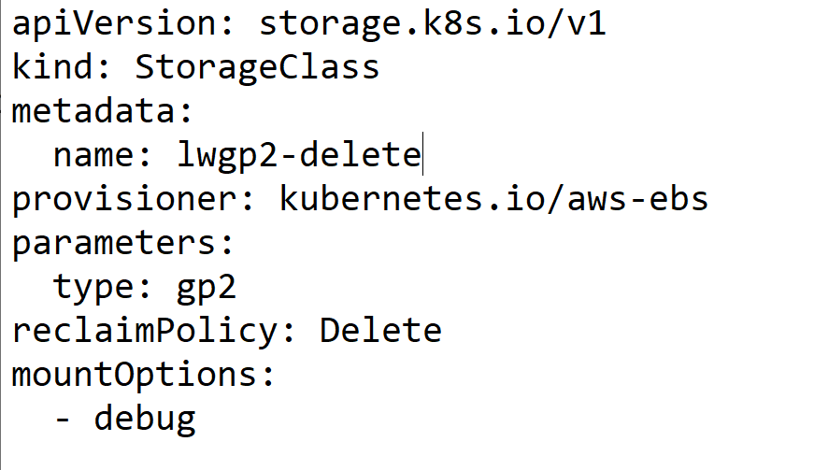

<https://kubernetes.io/docs/concepts/storage/storage-classes/#:~:text=A%20StorageClass%20provides%20a%20way,unopinionated%20about%20what%20classes%20represent.>

# yum install amazon-efs-utils

<https://github.com/kubernetes/dashboard>

<https://kubernetes.io/docs/tasks/access-application-cluster/web-ui-dashboard/>

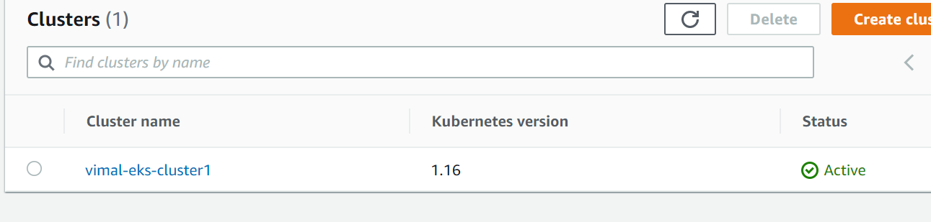

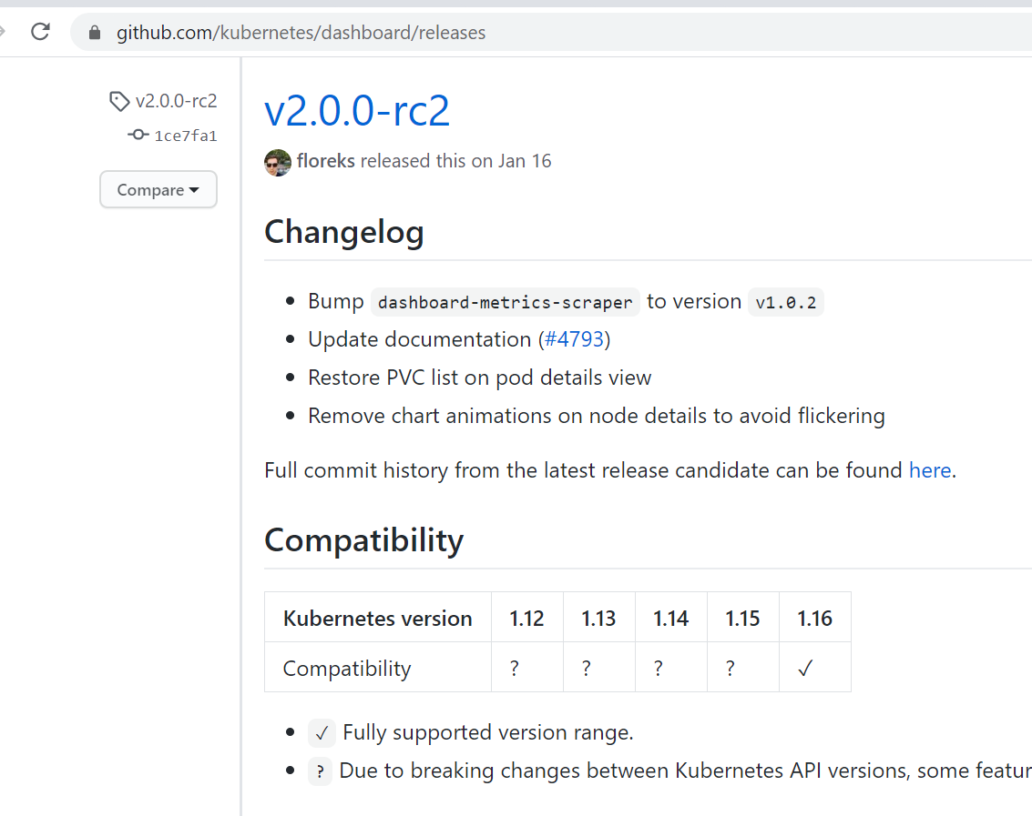

<https://github.com/kubernetes/dashboard/releases>

kubectl apply -f https://raw.githubusercontent.com/kubernetes/dashboard/v2.0.0-rc2/aio/deploy/recommended.yaml

# kubectl get pods -n kubernetes-dashboard

# kubectl proxy

<http://localhost:8001/api/v1/namespaces/kubernetes-dashboard/services/https:kubernetes-dashboard:/proxy/#/login>

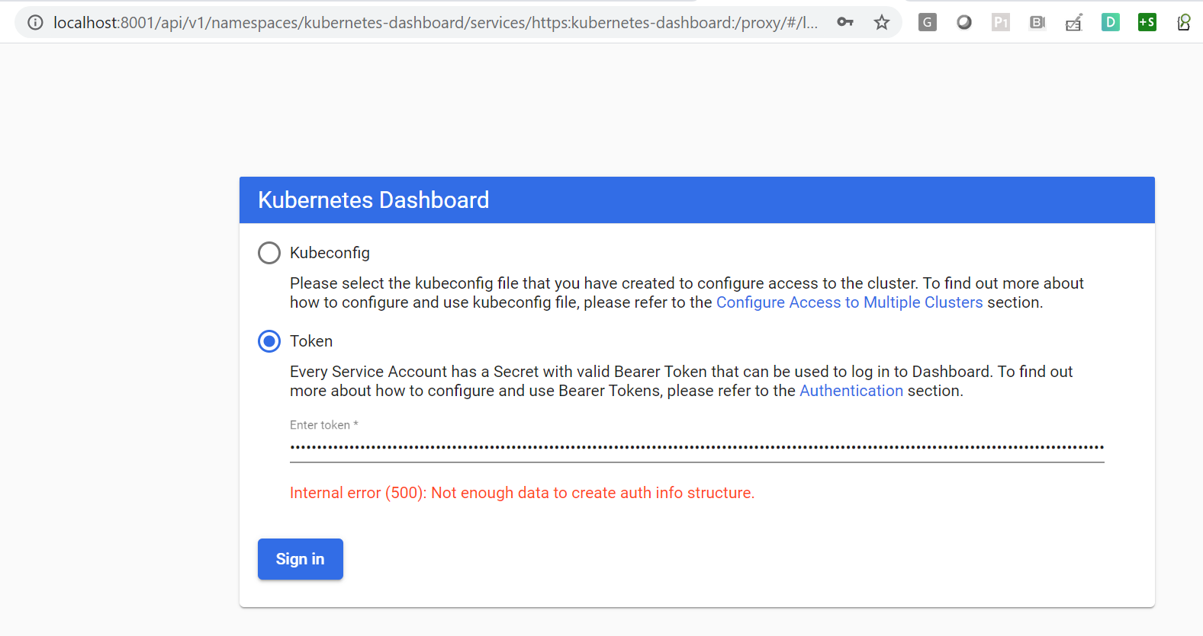

kubectl create serviceaccount dashboard-admin-sa

kubectl create clusterrolebinding dashboard-admin-sa

--clusterrole=cluster-admin --serviceaccount=default:dashboard-admin-sa

kubectl get secrets

kubectl describe secret dashboard-admin-sa-token-kw7vn

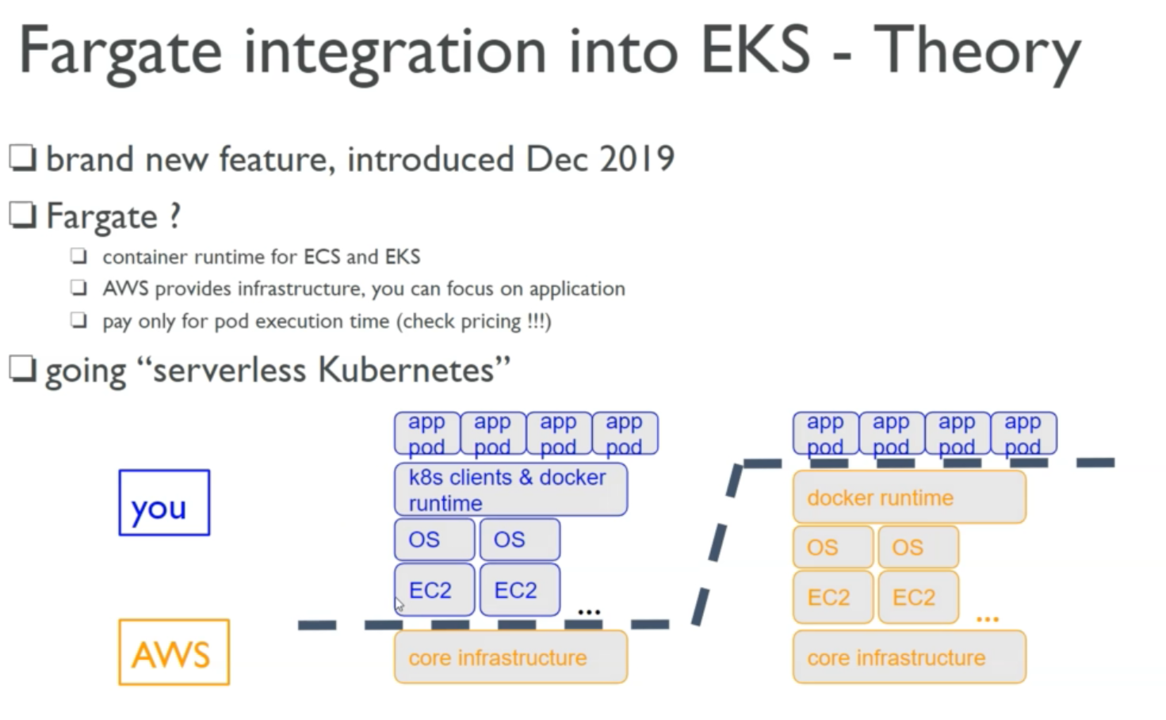

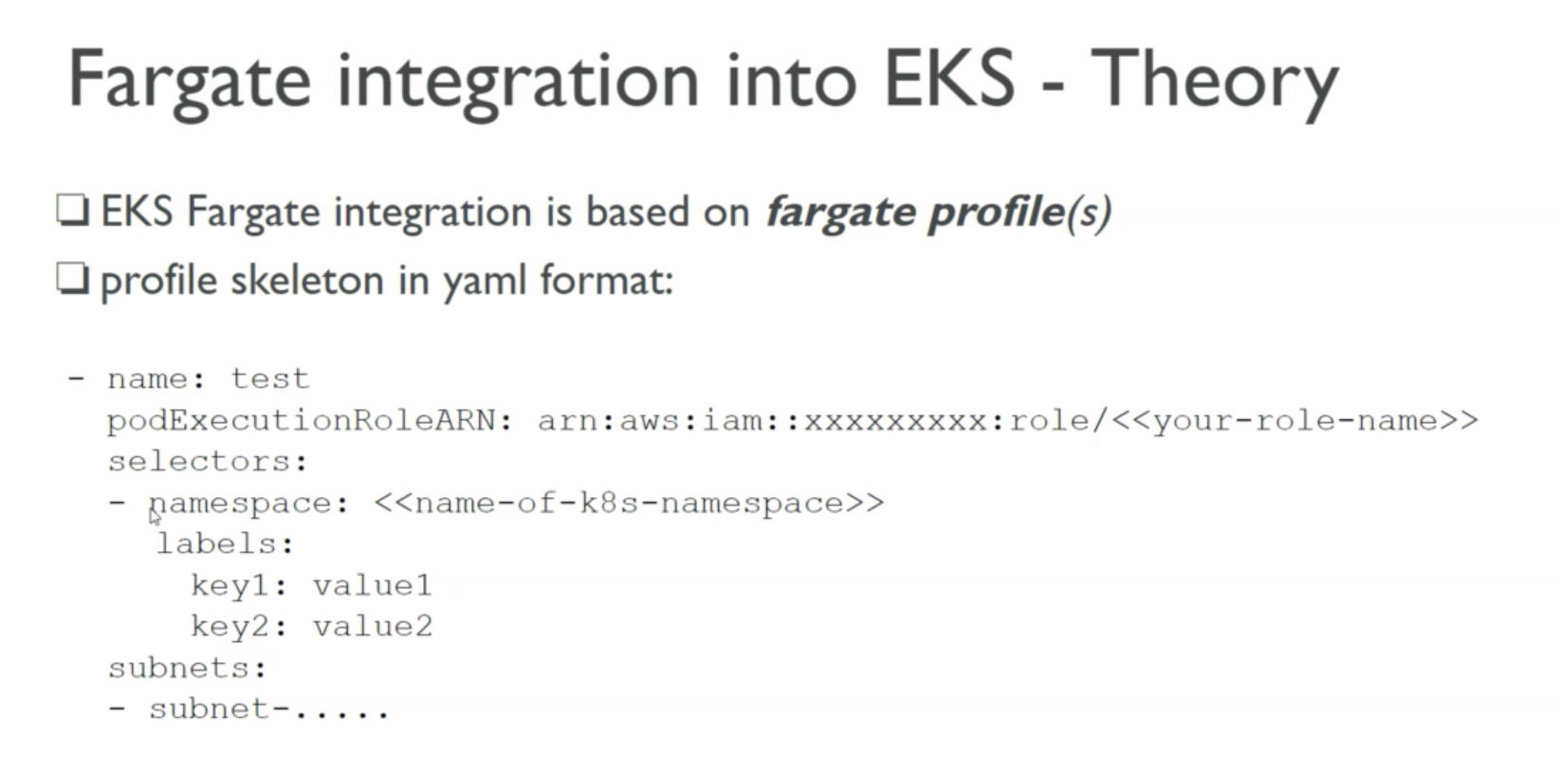

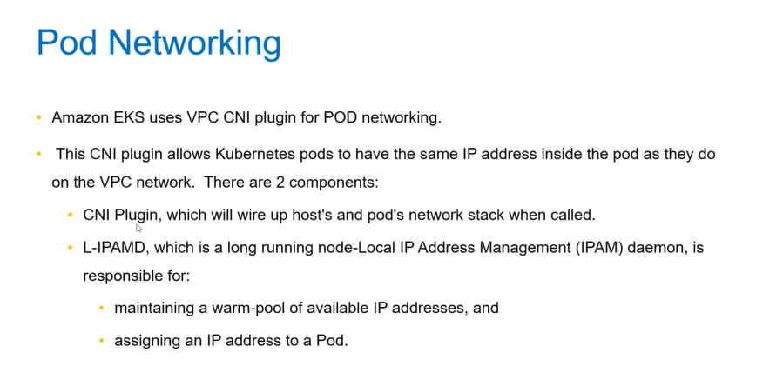

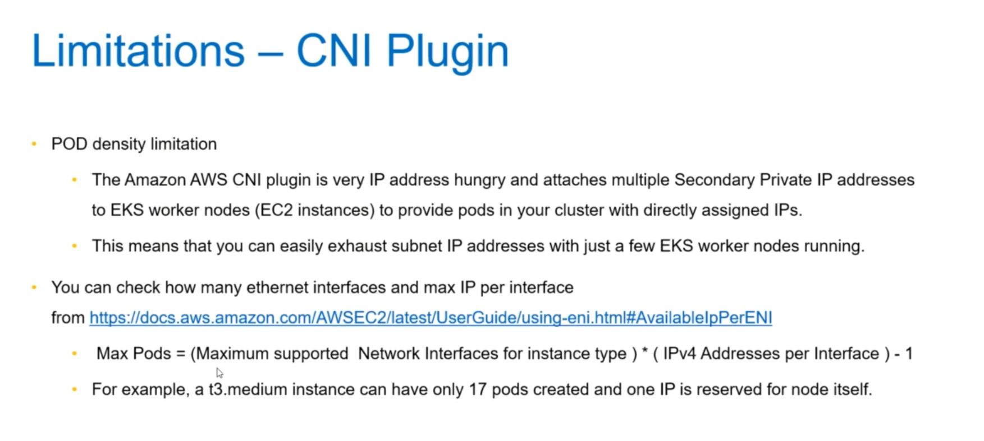

<https://docs.aws.amazon.com/eks/latest/userguide/pod-networking.html>

<https://docs.aws.amazon.com/eks/latest/userguide/cni-upgrades.html>

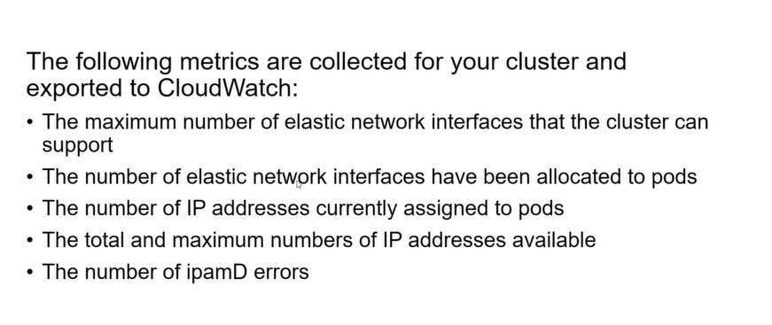

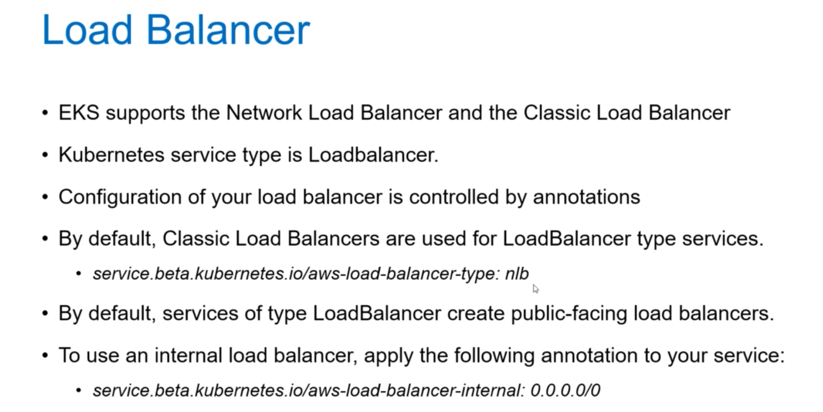

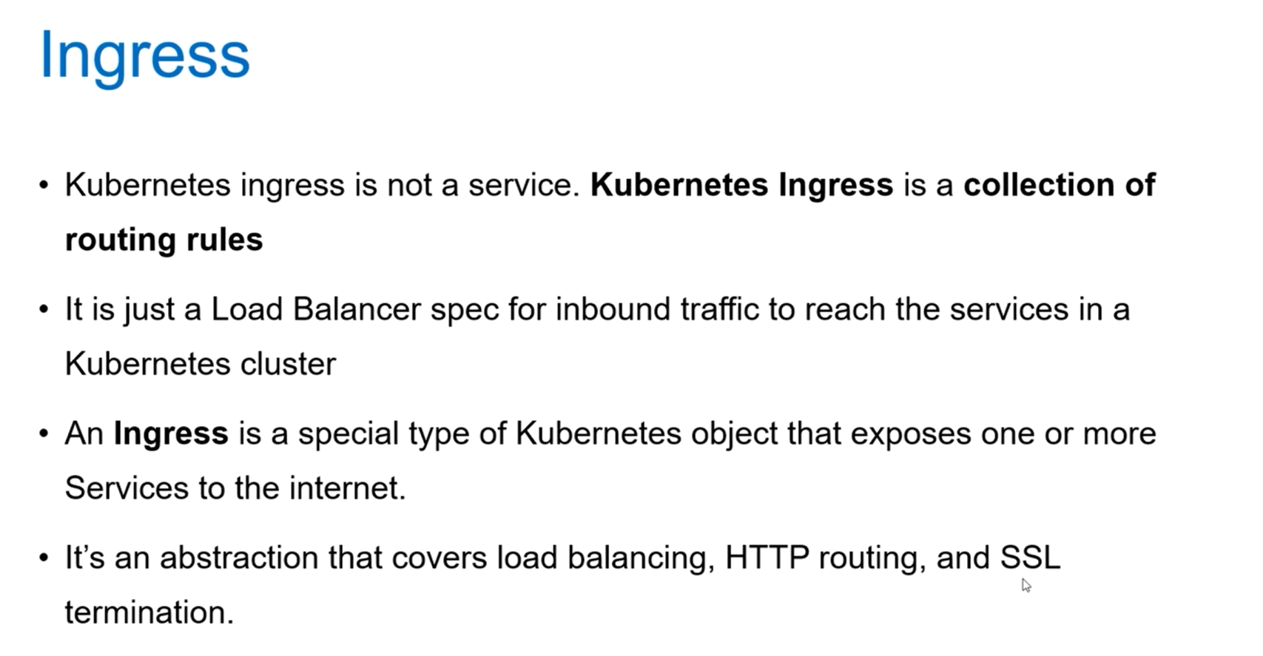

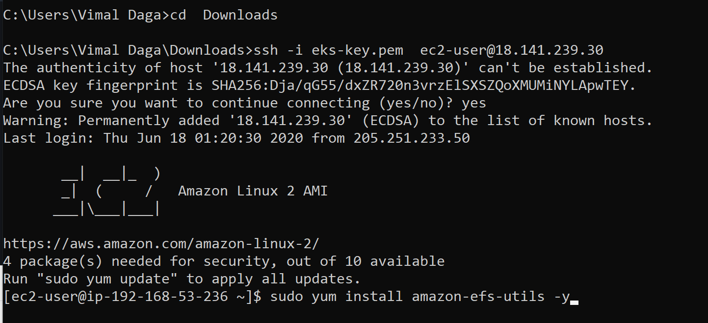

kubectl create ns lwns

kubectl create secret generic mysql-pass --from-literal=password=myredhat -n lwns

<https://github.com/helm/helm/releases>

# helm init

# helm repo add stable <https://kubernetes-charts.storage.googleapis.com/>

# helm repo list

# helm repo update

# kubectl -n kube-system create serviceaccount tiller

# kubectl create clusterrolebinding tiller --clusterrole cluster-admin --serviceaccount=kube-system:tiller

# helm init --service-account tiller

# kubectl get pods --namespace kube-system

# kubectl create namespace prometheus

# helm install stable/prometheus --namespace prometheus --set alertmanager.persistentVolume.storageClass="gp2" --set server.persistentVolume.storageClass="gp2"

# kubectl get svc -n prometheus

# kubectl -n prometheus port-forward svc/flailing-buffalo-prometheus-server 8888:80

# kubectl create namespace grafana

# helm install stable/grafana --namespace grafana --set persistence.storageClassName="gp2" --set adminPassword='GrafanaAdm!n' --set datasources."datasources\.yaml".apiVersion=1 --set datasources."datasources\.yaml".datasources[0].name=Prometheus --set datasources."datasources\.yaml".datasources[0].type=prometheus --set datasources."datasources\.yaml".datasources[0].url=http://prometheus-server.prometheus.svc.cluster.local --set datasources."datasources\.yaml".datasources[0].access=proxy --set datasources."datasources\.yaml".datasources[0].isDefault=true --set service.type=LoadBalancer

# kubectl get secret worn-bronco-grafana --namespace grafana -o yaml

